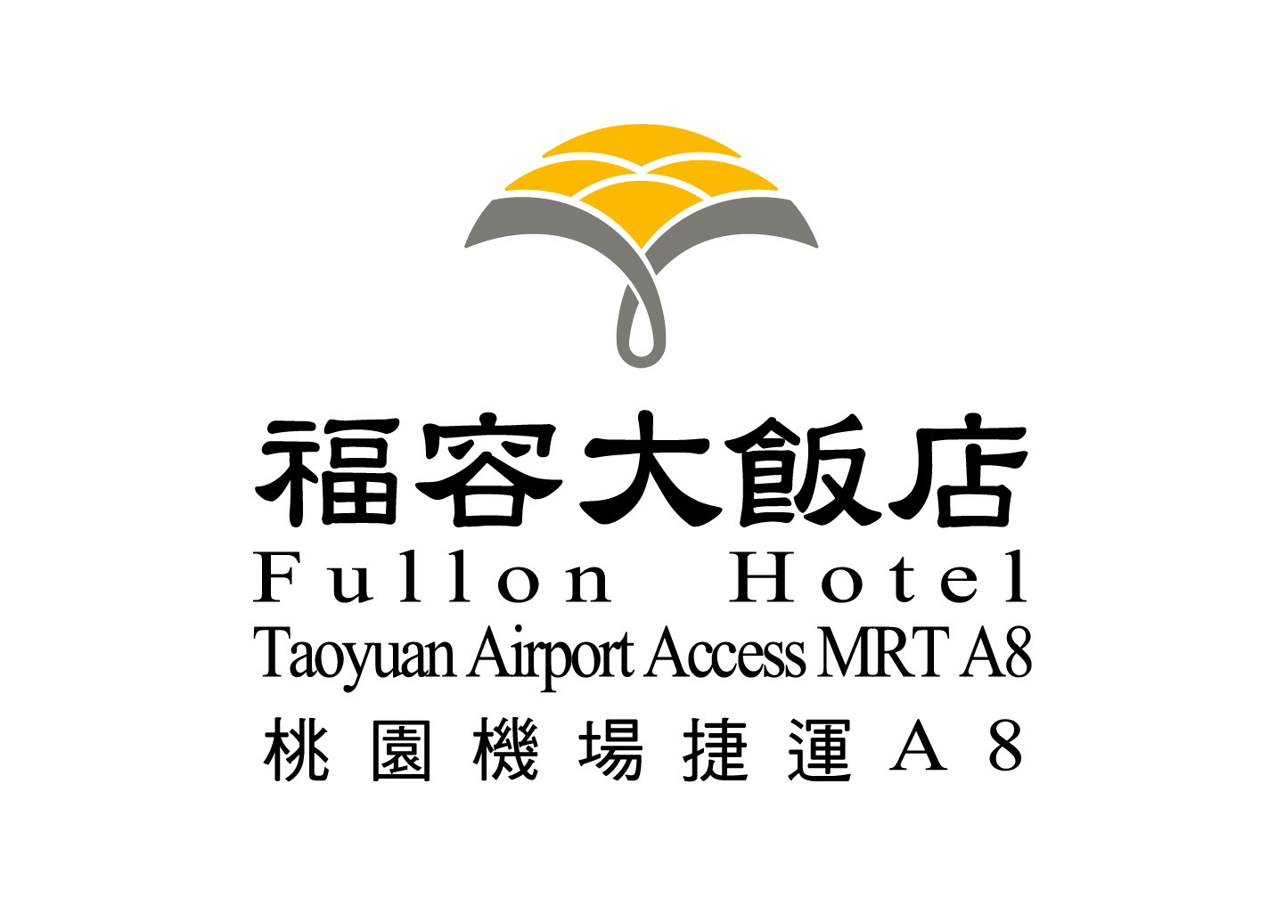
Chang Gung Forum 2025
Reservation Deadline 訂房期間: Sep 27th ~ Oct 1st, 2025
Fullon Hotel A8 Accommodation Reservation Request Form

請Email或傳真至訂房組Please Email or Fax to Hotel Reservation Department

Tel : +886-3-328-5688 Fax : + 886-3-328-8618 Email: lka8@fullon-hotels.com.tw
訂房代號Reservation No.<For Hotel Use Only>：
◻入住日期 Arrival Date： |  |  |  |  |  | ◻退房日期Departure Date：
◻房客姓名 Guest Name： |  |  |  |  |  |  |  | ◻航班號碼/時間Flight No./Time：
◻訂房聯絡人Contact Person： |  |  |  |  |  |  | ◻聯絡電話TEL：
◻電子郵箱 E-mail： |  |  |  |  |  |  | ◻傳真FAX：
間 數  No. of Room | 總人數  Occupancy | 房 型  Room type |  | 坪數  Ping | 床型  Bedding |  | 一般價  Rack Rate |  |  |  | 優惠價  Special Rate | 備註  Remark
 |  | 精緻單人房  Superior Single |  | 10 | 雙人床Double Bed (180cm x 200cm*1) |  | NT$ 4,356NET |  |  |  | NT$ 3,300NET | ※ Including 1 breakfast.
 |  | 精緻客房  Superior Room |  | 12 | 雙人床Double Bed  (240cm x 200cm*1) |  | NT$ 4,851NET |  |  |  | NT$ 3,800NET | ※ Including 1-2 breakfast.
 |  |  |  | 12 | 雙床房Twin Beds  (120cm x 200cm*2) |  |  |  |  |  | NT$ 3,800NET | ※ Including 1-2 breakfast.
 |  | 豪華客房  Deluxe Room |  | 14 | 雙人床Double Bed  (180cm x 200cm*1) |  | NT$ 5,346NET |  |  |  | NT$ 5,200NET | ※ Including 1-2 breakfast.
□ | 提早6:00 a.m.後入房將酌收50%的房租。/  Early check-in after 6:00 a.m. will be charged 50% of the room charge.
※以上價格含稅及10%服務費 / Above room rates are including 5% government tax and 10% service charge.
※房客享免費使用健身房/ Free access to Gym.
※房客享免費使用『黃金美人湯』三溫暖設施(每週四例行性清洗，清洗期間暫不提供服務) / Free access to Sauna(It will be closed temporarily for refreshing the natural hot spring water on every Thursday morning.).
※住房時間下午3時以後，退房時間至隔日中午11時止 / Check in time: 15:00 p.m.; Check out time: 11:00a.m..
※取消訂房請於三天前，預定房間若未到，將收取當日房租。
In case of cancellation less than 72 hours prior to arrival or no-show, 100% deposit will be charged for each room.
※為保留您的訂房，請填寫以下信用卡資料，需收到飯店提供之訂房確認書，方表示預訂完成且成功。
Credit card is required for the reservation guarantee; a deposit equal to one night’s room rate for each room will be charged to credit card at the time of booking. Confirmation letter will be sent to you once the booking has completed.
※如需接送機服務，請洽訂房組。For inquiries regarding airport transfer, please contact Reservation Department.
Reservation Guarantee (Please be advised that your booking will only be confirmed when given the following information)
卡別Credit Card |  |  | □ Visa □ Master □ AMEX □JCB □ OTHER |  |  |  |  |  | 有效日期  Card Expire date(MM/YY)
卡號Card Number
持卡人姓名Card Holder
持卡人簽Signature |  |  |  |  |  |  |  |  |  | 日期Date： / /
※房客可至桃園長庚轉運站搭乘至桃園分院大會會場的接駁車，桃園長庚轉運站與福容大飯店桃園機場捷
運A8店距離約步行8分鐘。
Guest can go to Taoyuan Chang Gung Bus Terminal to take Shuttle Bus to Chang Gung Memorial Hospital, Taoyuan. It is 8 minutes walking distance from Fullon Hotel MRT A8 to Taoyuan Chang Gung Bus Terminal.

Hotel: Fullon Hotel Taoyuan Airport Access MRT A8
Address: No. 2,Fuxing 1st Rd., Gueishan Dist.,
Taoyuan City 33380, Taiwan (R.O.C.)
Website: http://www.fullon-hotels.com.tw/a8/

